topic |  | Fusion of Hammer – Claw – Mallet Toe
Procedure |  | IP JOINT ARTHRODESIS (Fusion) WITH IMPLANT  - Toe Grip or Smart Toe  (Toe Grip or Smart Toe)
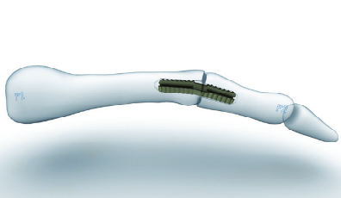
Toe Grip Implant
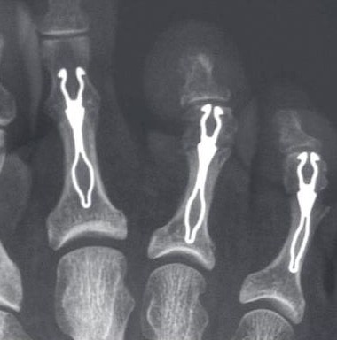
Smart Toe Implant

AIMS OF SURGERY | To reduce pain and deformity.  To improve the toe alignment [make straighter].  To reduce callous / corn formation
advantages of THIS OPERATION | Reduces the instability / malalignment which is the cause of the deformity
SPECIFIC RISKS of THIS OPERATION | Recurrence of the deformity  Toe may not touch the ground 10% (floating toe)  Increased prominence of adjacent toes  Weakness/lack of toe purchase |  | Revision surgery is necessary in 2%  Infection in 3%  Prolonged swelling

OVERVIEW
Operation time | Usually between 15 – 30 minutes
Incision placement / stitches | Usually on top of the toe and with absorbable or standard stitches
Procedure | A small piece of bone is removed from the small joint in the middle of your toe. An appropriately sized implant is used to fuse the joint straight. If necessary, the joint at the base of the toe may be released and the tendon lengthened.
Fixation | The Toe Grip implant or Smart Toe implant will be used to stabilise the toe while it is healing allowing for the bone fusion to take place. Providing post operatively there is irritation from the fixation, this is left in place.
Will I have plaster? | No
Is this a Day Procedure? | Yes, you can usually go home the same day
Estimated time off work | Non-manual work approximately 4-6 weeks  Manual work 6-8 weeks
INDICATIONS FOR The procedure | Painful hammer – claw – mallet toe deformity  Painful / prominent joint  Difficulty with shoe fit despite wearing sensible footwear
ALTERNATIVE TREATMENTS | Manage your symptoms by changing / activity levels, using painkillers, altering / footwear style. The use of toe protectors, regular podiatry care.
Patient Reported outcomes | The general risks of foot surgery are outlined in the Pre-operative Information Booklet which is provided in addition to this leaflet  YOU SHOULD READ THIS LEAFLET IN CONJUNCTION WITH THE PREOPERATIVE INFORMATION BOOKLET
MORE INFO By: | 1 Speaking with your consultant or one of his team  2 Reading the information provided

www.christopherwithey.co.uk
Surgery to correct Hammer – Claw – Mallet Toe

The operation can be performed comfortably under a Local Anaesthetic block, which is achieved by either a series of injections around the Ankle, or an injection behind your Knee. You will be fully awake during the operation and will be able to feel touch, pressure and vibration, but you will not feel any pain. If you do not wish to consider having the operation performed whilst still awake, or your Consultant does not feel this is the best option for you, you will be offered Local Anaesthetic with sedation or General Anaesthesia.

The operation takes about 15-30 minutes although you will be in the Day Surgery unit for some time before the surgery and afterwards, to allow you an opportunity to rest post operatively. You must have a competent adult at home for the first day and night after surgery. This allows us to be sure you will be safe for the first night.

First 2-4 days
- This is the time you are likely to have most pain but you will be given painkillers to help. You must rest completely for 2-4 days.
- You will be able to stand and take weight carefully (using crutches) after the operation, but you must rest, with your feet up, as much as possible.
- You should restrict your walking to going to the bathroom and when getting about use your crutches in the way you will have been shown.
- You can get about a little more after 3 days.

One week after surgery
- You may need to attend for your foot to be checked and re-dressed.
- You may start to do a little more within pain limits. Pain & swelling means you are doing too much.

Two weeks after surgery
- Sutures will be removed if necessary.
- You will not need a bandage or crutches any longer and can get the foot wet.
- You will be asked to start wearing trainer type shoes.

Between 2-6 weeks after surgery
- Any pin will be removed during this period.
- The foot starts to return to normal and you can return to shoes (4 -6 weeks).
- The foot will still be quite swollen especially at the end of the day.
- You may require a review appoint at 4-6 weeks
- You may return to work but may need longer if you have an active job
- You may return to driving if you can perform an emergency stop. You must check with your insurance company before driving again.

Between 6 -8 weeks after surgery
- The foot should continue to improve and begin to feel normal again.
- There will be less swelling.
- Sport can be considered after 3 months depending on your recovery.

Six months after surgery
- You will have a final review between 3- 6 months following surgery.
- The swelling should now be slight and you should be getting the full benefit of surgery.

Twelve months after surgery
- The foot has stopped improving with all healing complete.

Please note if a complication arises, recovery may be delayed.

www.christopherwithey.co.uk

