topic |  |  | HALLUX RIGIDUS
Procedure |  |  | 1st MTP JOINT FUSION
 | 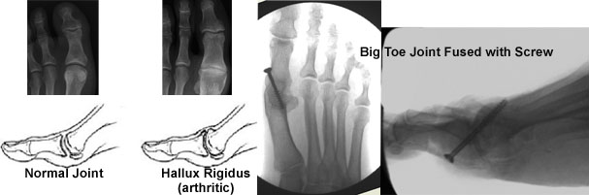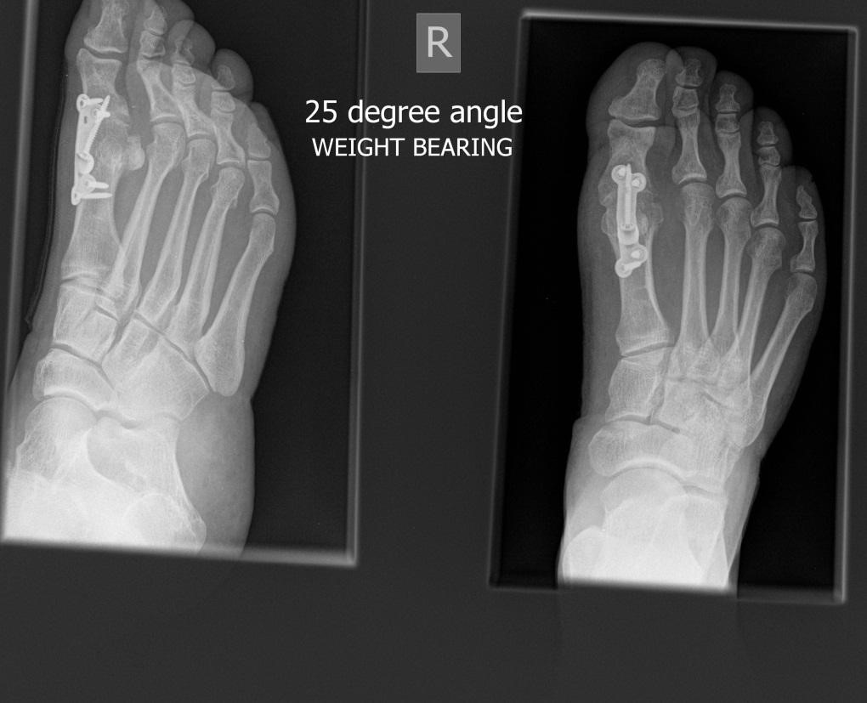
AIMS OF SURGERY |  | To reduce pain and deformity.  To improve the big toe alignment [make straighter].
advantages of THIS OPERATION |  | Reduces pain by removing any movement in the joint.  As a result, the outcome of the procedure is more predictable.  Definitive procedure
SPECIFIC RISKS of THIS OPERATION |  | Pressure lesion to big toe  Arthritis of the small joint in the big toe  Poor alignment |  | Non-union of bone (bone does not knit together)  Problems with fixation ( the screws/plates/pins)  Transfer of pressure to ball of foot.

OVERVIEW
Operation time |  | Usually between 45 to 60 minutes
Incision placement / stitches |  | Usually on top or side of the toe and with absorbable stitches where possible
Procedure |  | The bony surfaces either side of the big toe joint are cut away with a saw to remove the worn- out cartilage. The raw bone surfaces are then held together whilst they fuse (heal together).
Fixation |  | Internal fixation (bone screws, plates or wires) is used to hold the bone cut together. You will not notice these and they do not usually need to be removed
Will I have plaster? |  | This may be required for 4-8 weeks depending upon healing
Is this a Day Procedure? |  | Yes, you can usually go home the same day (you will usually be admitted for half a day)
Estimated time off work |  | Non-manual work approximately 6-8 weeks  Manual work approximately 8-10 weeks
INDICATIONS FOR The procedure |  | Unstable or arthritic 1st metatarsophalangeal joint  Difficulty with shoe fit despite wearing sensible footwear  Failure of alternative treatment
ALTERNATIVE TREATMENTS | Manage your symptoms by altering activity levels, using painkillers and anti inflammatories, extra depth / width shoes, rocker sole (stiff curved sole) using an insole or orthotic foot support, joint injection therapy. Other surgical options include 1st MTP joint excisional arthroplasty or joint implant.
GENERAL RISKS OF SURGERY | The general risks of foot surgery are outlined in the Pre-operative Information Booklet which is provided in addition to this leaflet
MORE INFO By: | 1 Speaking with your consultant or one of the team  2 Reading the information provided

1st MTP JOINT FUSION
The operation can be performed comfortably under a Local Anaesthetic block, which is achieved by either a series of injections around the Ankle, or an injection behind your Knee. You will be fully awake during the operation and will be able to feel touch, pressure and vibration, but you will not feel any pain. If you do not wish to consider having the operation performed whilst still awake, or your Consultant does not feel this is the best option for you, you will be offered Local Anaesthetic with sedation or General Anaesthesia.

The operation takes about 45-60 minutes although you will be in the Day Surgery unit for some time before the surgery and afterwards, to allow you an opportunity to rest post operatively. You must have a competent adult at home for the first day and night after surgery. This allows us to be sure you will be safe for the first night.

First 2-4 days
- This is the time you are likely to have most pain but you will be given painkillers to help. You must rest completely for 2-4 days.
- You will be able to stand and take weight carefully on your other foot (using crutches) after the operation, but you must rest, with your feet up, as much as possible.
- You should restrict your walking to going to the bathroom and when getting about use your crutches in the way you will have been shown.
- You can get about a little more after 3 days.

One week after surgery
- You may need to attend for your foot to be checked and re-dressed.
- You may start to do a little more within pain limits. An increase in pain can mean you are doing too much.

Two weeks after surgery
- You may need to attend again. Sutures will be removed if necessary.
- If you had a plaster cast another may be applied for a further 2-6 weeks.

At 4-8 weeks after surgery you will need to attend for a review. If you had a plaster cast it will be removed and the foot x-rayed.

- If the fusion site is healed you will be advised to wear trainer type shoes and begin to walk.
- The foot will still be quite swollen especially at the end of the day.
- You may return to work but may need longer if you have an active job
- You may return to driving if you can perform an emergency stop. You must check with your insurance company before driving again.

Between 8-12 weeks after surgery
- The foot should continue to improve and begin to feel normal again.
- There will be less swelling.
- Sport can be considered after 3 months depending on your recovery.

Six months after surgery
- You will have a final review between 3- 6 months following surgery.
- The swelling should now be slight and you should be getting the full benefit of surgery.

Twelve months after surgery
- The foot has stopped improving with all healing complete.

Please note, if a complication arises, recovery may be delayed.

