topic |  |  | Arthritis of the metatarsal head
Procedure |  |  | CartivaTM SCI (Synthetic Cartilage Implant)
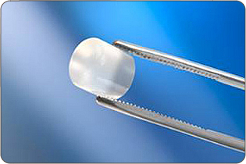
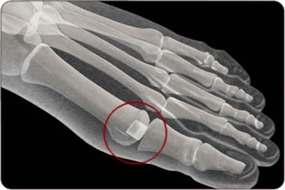
AIMS OF SURGERY |  | To reduce pain and deformity  To improve the toe joint mobility
advantages of THIS OPERATION |  | Improve range of movement at the MTP Joint  Does not require immobilisation
SPECIFIC RISKS of THIS OPERATION |  | Joint stiffness (due to jamming) (0.72%)  Implant movement (1.44%)  Implant reaction/prolonged swelling/pain |  | Increased risk of infection (1.45%)  Wear/disintegration of the implant  Transfer of weight to ball of foot (6.52%)

OVERVIEW
Operation time | Usually between 45 - 60 minutes
Incision placement / stitches | Usually on top of the toe and with absorbable stitches where possible
Procedure | The damaged surfaces of the toe joint are removed with a saw and the Cartiva SCI is inserted into the bone
Fixation | An organic polymer-based biomaterial of polyvinyl alcohol device that mimics natural cartilage is implanted
Will I have plaster? | No
Is this a Day Procedure? | Yes, you can usually go home the same day (you will usually be admitted for half a day)
Estimated time off work | Non-manual work for approximately 4 weeks  Manual work at approximately 6 weeks
INDICATIONS FOR The procedure | Arthritic metatarsophalangeal joint  Cartilage defect  Pain from prominent joint and/or stiff toe
ALTERNATIVE TREATMENTS | Manage your symptoms by altering activity levels, using painkillers and anti inflammatories, changing footwear, using an insole or orthotic foot support, joint injection therapy.  Surgical procedures include arthrodesis, excisional arthroplasty, exostectomy or decompression osteotomy.
GENERAL RISKS OF SURGERY | The general risks of foot surgery are outlined in the Pre-operative Information Booklet which is provided in addition to this leaflet  YOU SHOULD READ THIS LEAFLET IN CONJUNCTION WITH THE PREOPERATIVE INFORMATION BOOKLET
MORE INFO By: | 1 Speaking with your consultant or one of the team  2 Reading the information provided

CartivaTM SCI (Synthetic Cartilage Implant)
The operation can be performed comfortably under a Local Anaesthetic block or general anaesthetic.

The operation takes about 45-60 minutes, although you will be in the Day Surgery unit for some time before the surgery and afterwards, to allow you an opportunity to rest post operatively. You must have a competent adult at home for the first day and night after surgery. This allows us to be sure you will be safe for the first night.

First 2-4 days
- This is the time you are likely to have most pain but you will be given painkillers to help. You must rest completely for 2-4 days.
- You will be able to stand and take weight carefully (using crutches) after the operation, but you must rest, with your feet up, as much as possible.
- You should restrict your walking to going to the bathroom and when getting about use your crutches in the way you will have been shown.
- You can get about a little more after 3 days.

One week after surgery
- You may need to attend for your foot to be checked and re-dressed.
- You may start to do a little more within pain limits. An increase in pain can mean you are doing too much.
- You may be asked to move your toe through a range of motion to maintain mobility.

Two weeks after surgery
- Sutures will be removed if necessary.
- You will not need a bandage or crutches any longer and can get the foot wet.
- You will be asked to start wearing trainer type shoes.

Between 2-6 weeks after surgery
- The foot starts to return to normal and you can return to shoes (6-8 weeks) (89%).
- The foot will still be quite swollen especially at the end of the day.
- You may return to work but may need longer if you have an active job
- You may return to driving if you can perform an emergency stop. You must check with your insurance company before driving again.
- Whilst normal activity will be resumed, sport should be avoided.

Between 8-12 weeks after surgery
- The foot should continue to improve and begin to feel normal again.
- There will be less swelling.
- Sport can be considered after 3 months depending on your recovery.

Six months after surgery
- You will have a final review between 3- 6 months following surgery.
- The swelling should now be slight and you should be getting the full benefit of surgery.

Twelve months after surgery
- The foot has stopped improving with all healing complete.

Please note, if a complication arises, recovery may be delayed

